DIS-Pipes-TN- Platform

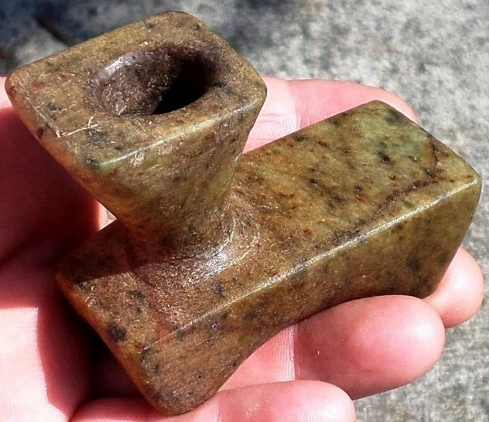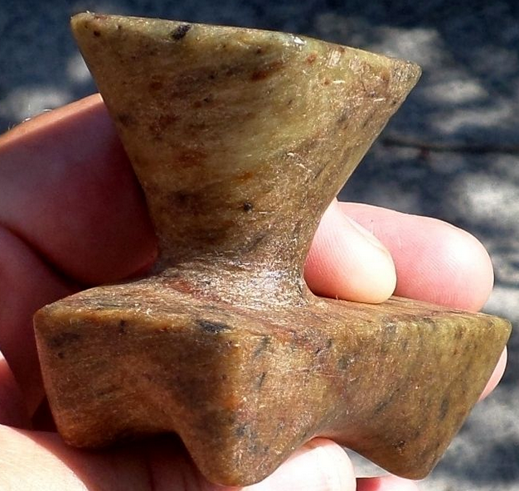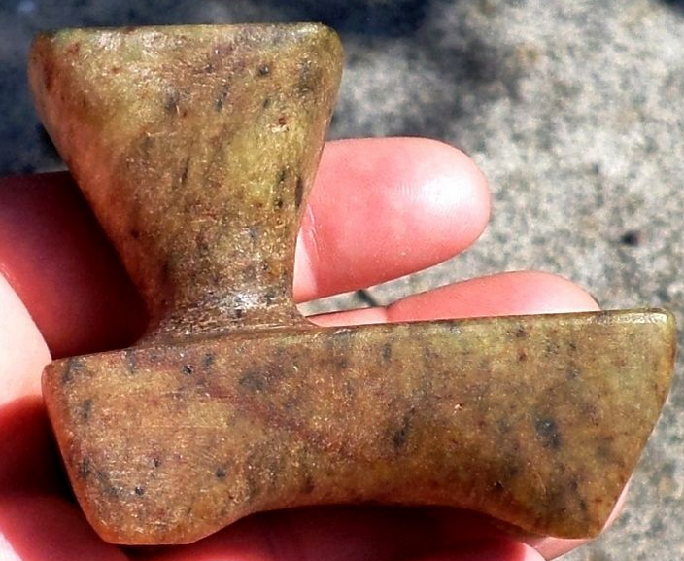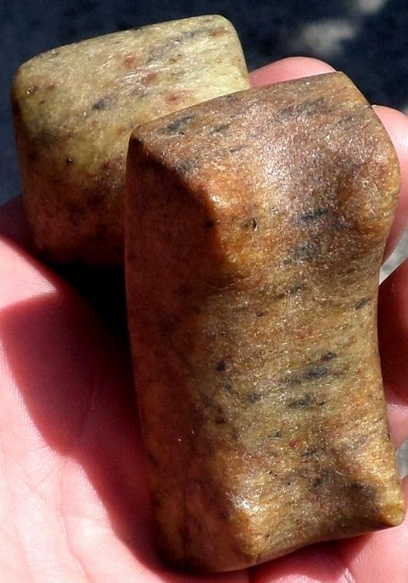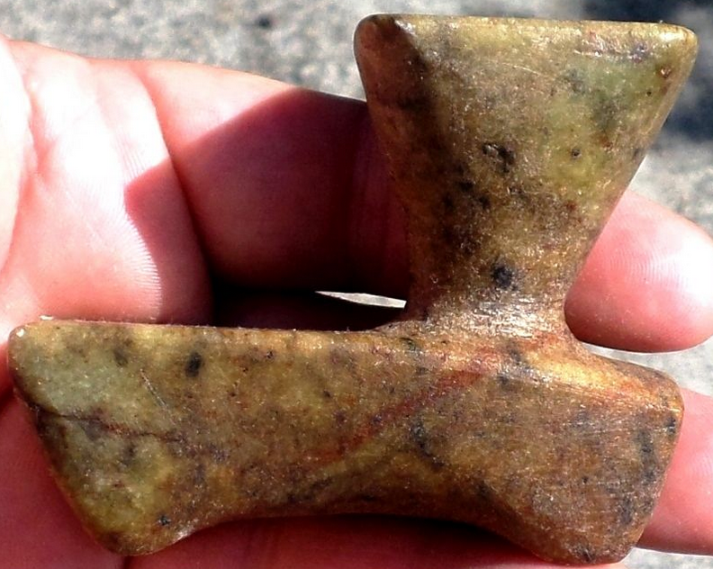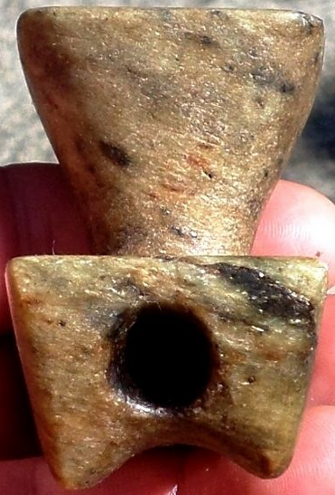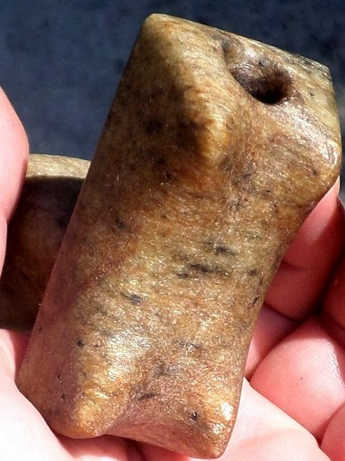

Platform pipe with four small ‘feet’ on the bottom that measures 2 7/8” x 2 1/4” x 1 1/2”. This is a very good-looking piece with a square bowl that sits very high above the base. The pipe is in very nice condition and is part of a large collection from Cocke County, Tennessee.

|  |  |
| --- | --- |
| ORDER DATE  Oct 22, 2015 | ORDER TOTAL  US $209.99  + US $24.00  shipping  **Order 193808087012!551254792018** [View order details](http://payments.ebay.com/ws/eBayISAPI.dll?ViewPaymentStatus&transId=0&itemid=171969755160&_trksid=p2057872.m2749.l2673)[Contact seller](http://contact.ebay.com/ws/eBayISAPI.dll?ShowSellerFAQ&requested=tnreliccollector&iid=171969755160&redirect=0&_trksid=p2057872.m2749.l2652)  [More actions](http://www.ebay.com/myb/PurchaseHistory) |

4 items sold by[tnreliccollector](http://www.ebay.com/usr/tnreliccollector?_trksid=p2057872.m2749.l2754)

|  |  |  |
| --- | --- | --- |
| [WP2 Grooved Stone Plummet Native American Relic Indian Artifact Pendant](http://www.ebay.com/itm/171969755160?_trksid=p2057872.m2749.l2649&ssPageName=STRK%3AMEBIDX%3AIT)  ( 171969755160 )  Estimated delivery Wed, Oct 28  [Add note](javascript:;) | ITEM PRICE:  US $17.00 | **Item WP2 Grooved Stone Plummet Native American Relic Indian Artifact Pendant Orders 171969755160-0-0**[Leave feedback](http://feedback.ebay.com/ws/eBayISAPI.dll?LeaveFeedbackShow&useridto=tnreliccollector&transactID=0&item=171969755160&_trksid=p2057872.m2749.l2665)[Return this item](http://postorder.ebay.com/Return/ReturnViewSelectedItem?transactionId=0&itemId=171969755160&_trksid=p2057872.m2749.l3185)  [More actions](http://www.ebay.com/myb/PurchaseHistory) |

|  |  |  |
| --- | --- | --- |
| [SP1 Black Steatite Wolverine Effigy Pipe Indian Stone Artifact Native American](http://www.ebay.com/itm/181903906189?_trksid=p2057872.m2749.l2649&ssPageName=STRK%3AMEBIDX%3AIT)  ( 181903906189 )  Estimated delivery Wed, Oct 28  [Add note](javascript:;) | ITEM PRICE:  US $81.00 | **Item SP1 Black Steatite Wolverine Effigy Pipe Indian Stone Artifact Native American Orders 181903906189-0-0**[Leave feedback](http://feedback.ebay.com/ws/eBayISAPI.dll?LeaveFeedbackShow&useridto=tnreliccollector&transactID=0&item=181903906189&_trksid=p2057872.m2749.l2665)[Return this item](http://postorder.ebay.com/Return/ReturnViewSelectedItem?transactionId=0&itemId=181903906189&_trksid=p2057872.m2749.l3185)  [More actions](http://www.ebay.com/myb/PurchaseHistory) |

|  |  |  |
| --- | --- | --- |
| [CU3 Indian Stone Artifact Platform Pipe w/Feet Native American Relic Tennessee](http://www.ebay.com/itm/181903907735?_trksid=p2057872.m2749.l2649&ssPageName=STRK%3AMEBIDX%3AIT)  ( 181903907735 )  Estimated delivery Wed, Oct 28  [Add note](javascript:;) | ITEM PRICE:  US $99.99 | **Item CU3 Indian Stone Artifact Platform Pipe w/Feet Native American Relic Tennessee Orders 181903907735-0-0**[Leave feedback](http://feedback.ebay.com/ws/eBayISAPI.dll?LeaveFeedbackShow&useridto=tnreliccollector&transactID=0&item=181903907735&_trksid=p2057872.m2749.l2665)[Return this item](http://postorder.ebay.com/Return/ReturnViewSelectedItem?transactionId=0&itemId=181903907735&_trksid=p2057872.m2749.l3185)  [More actions](http://www.ebay.com/myb/PurchaseHistory) |

|  |  |
| --- | --- |
| [WB1 Large Triangle Bead Native American Relic Indian Stone Artifact Tennessee](http://www.ebay.com/itm/181903909393?_trksid=p2057872.m2749.l2649&ssPageName=STRK%3AMEBIDX%3AIT)  ( 181903909393 )  Estimated delivery Wed, Oct 28  [Add note](javascript:;) | ITEM PRICE:  US $12.00 |